|  |
| --- |
| detail of persons hands with scissors, markers, workingPREPARE AND EXPLORE THE DATA FOR DEFAULTS ON LOANS |
|  |

|  |  |  |
| --- | --- | --- |
| CREDIT ONE |  |  |
| Prepared for **Guido Rossum**  Prepared by **Lucia Oviedo**  July 29, 2020 |  |  |

Table of Contents

Overview 3

Getting to know our data 3

Prepare and Explore the data 4

Data Types 4

Correlation 5

Covariance Estimation 6

EDA 7

GENDER 7

AGE 7

AGE Vs GENDER 7

EDUCATION 8

MARRIAGE 8

DEFAULT VS LIMIT / EDUCATION 8

DEFAULT VS LIMIT / AGE 9

DEFAULT VS LIMIT_BAL / PAY_1 9

DEFAULT VS BILL_AMT / PAY_1 10

Feature Engineering and Dimensionality Reduction 11

One-Hot Encoding 12

Classification 13

Model Tuning 14

Model Evaluation 1

Investigative Questions: 1

# Overview

Problem:

An increase in customer default rates is bad for Credit One since its business is approving customers for loans in the first place. This is likely to result in the loss of Credit One's business customers.

## Getting to know our data

We have a data set with 30000 entries and 25 columns

Attribute Information:

LIMIT_BAL Amount of the given credit (NT dollar): it includes both the individual consumer credit and his/her family (supplementary) credit.

SEX (1 = male; 2 = female).

EDUCATION (1 = graduate school; 2 = university; 3 = high school; 0, 4, 5, 6 = others). *** unify others to one unique value

MARRIAGE (1 = married; 2 = single; 3 = divorce; 0=others).

AGE (year).

PAY_1 ... PAY_6 History of past payment (from April to September, 2005)

-2: No consumption;

-1: Paid in full;

0: The use of revolving credit;

1 = payment delay for one month;

2 = payment delay for two months; . . .;

8 = payment delay for eight months;

9 = payment delay for nine months and above.

BILL_AMT1 ... BILL_AMT6 Amount of bill statement (NT dollar) (September 2005 to April 2005)

PAY_AMT1 ... PAY_AMT6 Amount of previous payment (NT dollar) (September 2005 to April 2005)

DEFAULT Y=0 then not default, Y=1 then default"

# Prepare and Explore the data

### Data Types

Nominal values: SEX, EDUCATION, MARRIAGE, Default Payment next month (not standard name needs to get renamed), PAY_0 .... PAY_6

Numeric values: LIMIT_BAL, AGE, BILL_AMT1 .... BILL_AMT6, PAY_AMT1 .... PAY_AMT6

Statistical Analysis

* LIMIT_BAL mean value of credit amount is 167484.322667
* AGE mean value of years old that ask for credit is 35.485500
* BILL_AMT average goes from 38871.760400 to 51223.330900 and it is increasing every month
* PAY_AMT average of the pay amount goes from 5215.502567 to 5921 and it is increasing every month

Incongruence found:

Maximum LIMIT_BAL US 1,000,000 and max BILL_AMT3 is 1,664,089 witch is over the LIMIT_BAL.

This observation has a LIMIT_BAL of 500000 but bill_amt3 is of 1664089 (three times more than the LIMIT_BAL). PAY_AMT2 is of $1,684,259 getting a negative balance.

A deeper analysis of all the BILL_AMT that is greater than LIMIT_BAL plus 30% of loan interest was made. And 498 observations out of 30,000 has a bill amount much greater than the limit balance (1.6% of the Data Set) Need to follow and client should identify the root cause of this flaw.

### Correlation

High correlation was detected for PAY_1, PAY_2, PAY_3, PAY_4, PAY_5, PAY_6, EDUCATION and AGE

|  |  |
| --- | --- |
|  | DEFAULT |
| DEFAULT | 1 |
| PAY_1 | 0.324794 |
| PAY_2 | 0.263551 |
| PAY_3 | 0.235253 |
| PAY_4 | 0.216614 |
| PAY_5 | 0.204149 |
| PAY_6 | 0.186866 |
| EDUCATION | 0.033842 |
| AGE | 0.01389 |
| BILL_AMT6 | -0.005372 |
| BILL_AMT5 | -0.00676 |
| BILL_AMT4 | -0.010156 |
| BILL_AMT3 | -0.014076 |
| BILL_AMT2 | -0.014193 |
| BILL_AMT1 | -0.019644 |
| MARRIAGE | -0.024339 |
| SEX | -0.039961 |
| PAY_AMT6 | -0.053183 |
| PAY_AMT5 | -0.055124 |
| PAY_AMT3 | -0.05625 |
| PAY_AMT4 | -0.056827 |
| PAY_AMT2 | -0.058579 |
| PAY_AMT1 | -0.072929 |
| LIMIT_BAL | -0.15352 |

# Covariance Estimation

* Positive trends of DEFAULT: EDUCATION, AGE, PAY_1 .... PAY_6
* Negative trends of DEFAULT: LIMIT_BAL, SEX, MARRIAGE, BILL_AMT1 ... BILL_AMT6, PAY_AMT1 ... PAY_AMT6

|  |  |
| --- | --- |
| Feature | DEFAULT |
| DEFAULT | 0.172276 |
| PAY_1 | 0.151499 |
| PAY_2 | 0.13096 |
| PAY_3 | 0.116867 |
| PAY_4 | 0.105115 |
| PAY_5 | 0.09602 |
| PAY_6 | 0.089194 |
| AGE | 0.053143 |
| EDUCATION | 0.010458 |
| MARRIAGE | -0.005273 |
| SEX | -0.008113 |
| BILL_AMT6 | -132.796294 |
| BILL_AMT5 | -170.597447 |
| BILL_AMT4 | -271.199885 |
| PAY_AMT5 | -349.56253 |
| PAY_AMT4 | -369.515887 |
| PAY_AMT6 | -392.426415 |
| BILL_AMT3 | -405.15368 |
| PAY_AMT3 | -411.076284 |
| BILL_AMT2 | -419.289137 |
| PAY_AMT1 | -501.374552 |
| PAY_AMT2 | -560.21074 |
| BILL_AMT1 | -600.394108 |
| LIMIT_BAL | -8267.55176 |

# EDA

### GENDER

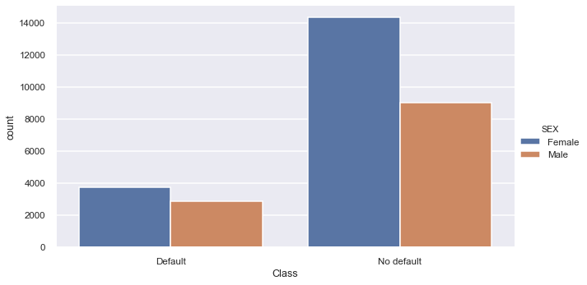

* As we already know from Correlation, there is no relation on SEX and default behavior.
* There is a higher number of defaults for females but also there is a higher number of no defaults for females

### AGE

* Customers with less than 30 years old has a higher count for credit loans in the data set.
* Customers from 20-34 years old has a higher default count in the data set, followed by 35-49 and 50-64.

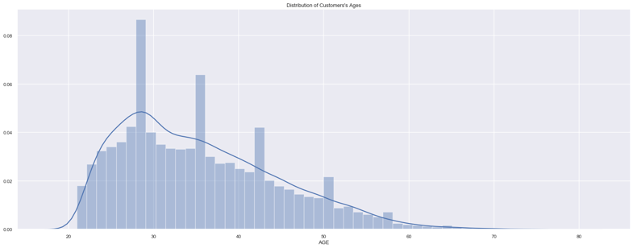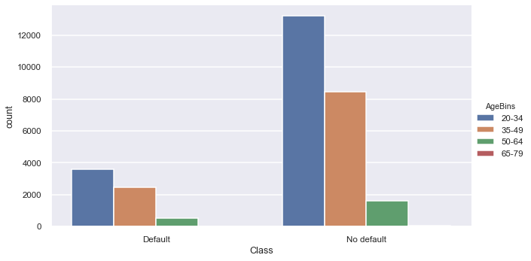

### AGE Vs GENDER

* Distribution is pretty much the same, there are more females count for credit loans in the data set

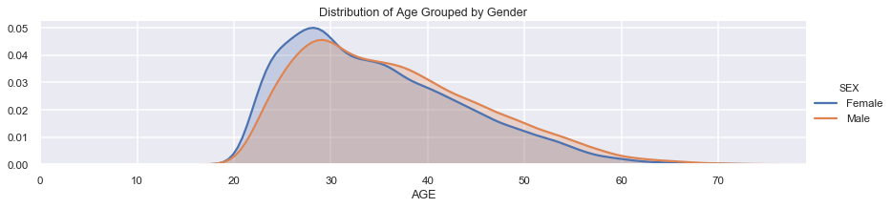

### EDUCATION

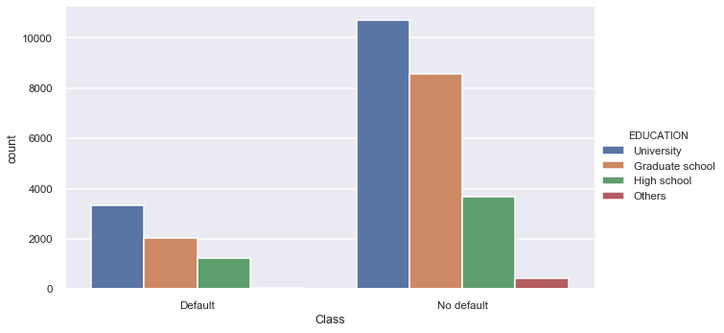

* Customers with a University degree has a higher default count in the data set, followed by Graduate school and High School degree.
* Others has not Default data

### A screenshot of a cell phone Description automatically generatedMARRIAGE

* As we already detected in correlation, Marriage doesn’t have a correlation with default

### DEFAULT VS LIMIT / EDUCATION

* In average customers who has default has a LIMIT_BAL AVERAGE OF 200,000
* In average customers who are Graduate School has a higher LIMIT_BAL, followed by OTHERS
* In average customers who DEFAULD and are Graduate School has a higher LIMIT_BAL
* In average customers who DEFAULD and are High School has a lower LIMIT_BAL

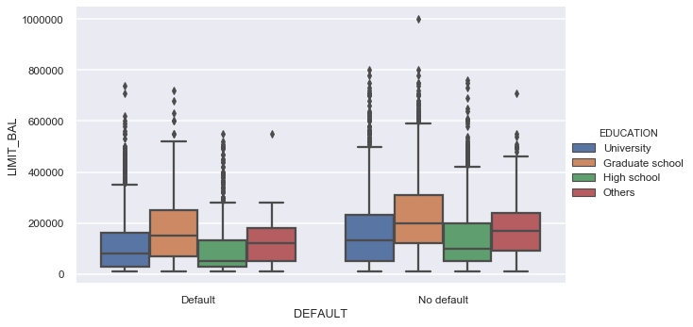

### DEFAULT VS LIMIT / AGE

* In average customers from 65 -79 years old has a higher LIMIT_BAL of 200000, followed by 35-49
* In average customers in the range 35-49 and 50-64 has the lowest and almost the same LIMIT_BAL
* In average customers who DEFAULT has a lower LIMIT_BAL than people who don't DEFAULT

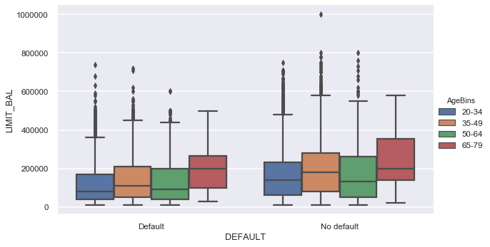

### DEFAULT VS LIMIT_BAL / PAY_1

* Pay in Full is found under Default Data, it might be an inconsistency
* I would suggest lower the Limit credit amount for those customers that has a delayed payment of 5 or more months. We can compare them against those customers who doesn’t default and those who actually DEFAUL has a higher LIMIT_BAL. Same goes for PAY_2 … PAY_8

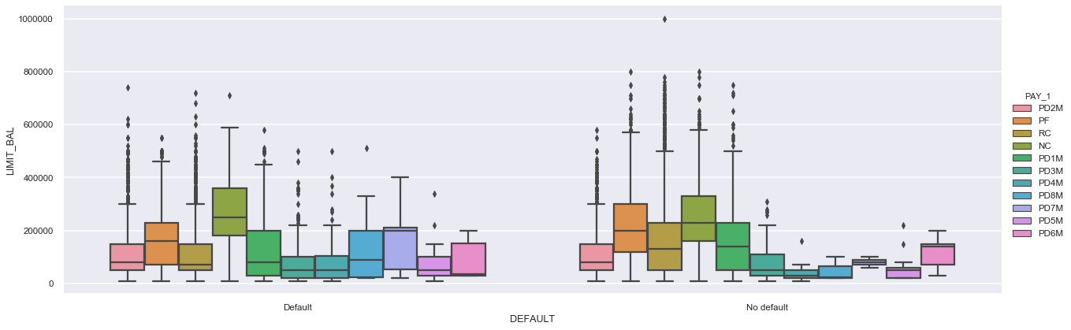

### DEFAULT VS BILL_AMT / PAY_1

* As expected, we can detect a bigger BILL_AMT1 for payment delay for 4 months to 8 months
* Pay in full is low for PAY_AMT1

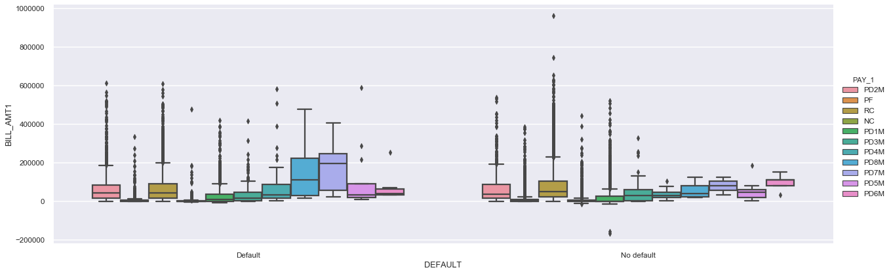

# Feature Engineering and Dimensionality Reduction

To implement feature engineering recursive feature selection with cross-validation was implemented using Random Forest Algorithm.

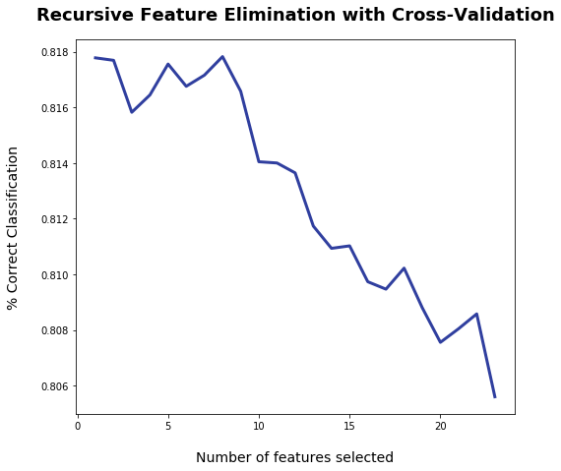

A optimal number of 8 best features were detected: LIMIT_BAL, PAY_1, PAY_2, PAY_3, PAY_4, PAY_5, BILL_AMT2 and PAY_AMT1'.

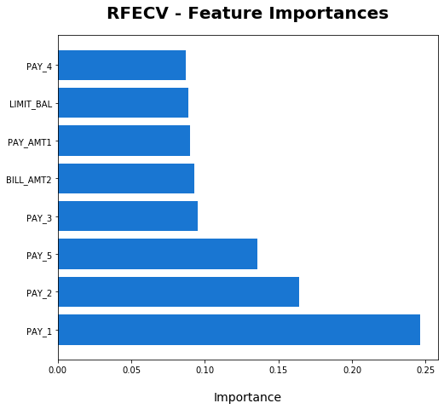

# One-Hot Encoding

One – Hot Encoding was implemented for the nominal features: 'SEX, EDUCATION and MARRIAGE.

One Hot Encoding was also implemented for PAY1, PAY2, … PAY6 but it has no significant improvement while running the building the models.

# Classification

The below classifiers were chosen to build our models.

* **GradientBoostingClassifier**
* **RandomForestClassifier**
* **AdaBoostClassifier**
* LinearDiscriminantAnalysis
* DecisionTreeClassifier
* SVC
* KNeighborsClassifier

From these classifiers the tree-based algorithms were the ones that shown better performance measure after building the models.

# Model Tuning

Form the selected classifiers, Random Forest Classifier was tuned using different values for n_estimators and max_depth.

Gradient Boosting Classifier was tuned using different values for n_estimators, learning_rate, subsample and max_depth.

# Model Evaluation

* The best models were for One Hot Encoding data, getting Accuracy of 100% with for GradientBoostingClassifier tuned with a max_depth=2.
* We noticed that the best classifiers were GradientBoostingClassifier, AdaBoostClassifier, DecisionTreeClassifier, RandomForestClassifier.
* Also, the best model implementing all features was for GradientBoostingClassifier using {'learning_rate': 0.1, 'max_depth': 4, 'n_estimators': 100, 'subsample': 1.0}
* Even though we had accuracy of 100% and precision and recall of 1, there is a possibility of model overfitting.

|  |  |  |  |  |
| --- | --- | --- | --- | --- |
| Model | Model2 | Accuracy | Classification Report | Cross Validation |
| OHE | GradientBoostingClassifier | 100.00% | precision recall f1-score support   0 1.00 1.00 1.00 5873  1 **1.00 1.00** 1.00 1627 | [1. 1. 1. 1. 1.] |
| OHE | AdaBoostClassifier | 100.00% | precision recall f1-score support   0 1.00 1.00 1.00 5873  1 **1.00 1.00** 1.00 1627 | [1. 1. 1. 1. 1.] |
| OHE | DecisionTreeClassifier | 100.00% | precision recall f1-score support   0 1.00 1.00 1.00 5873  1 **1.00 1.00** 1.00 1627 | [1. 1. 1. 1. 1.] |
| OHE | RandomForestClassifier | 88.96% | precision recall f1-score support   0 0.88 1.00 0.93 5873  1 **1.00 0.49** 0.66 1627 | [0.898 0.95 0.86466667 0.902 0.84 ] |
| RFE | RandomForestClassifier | 82.43% | precision recall f1-score support   0 0.85 0.95 0.89 5873  1 **0.66 0.38** 0.49 1627 | [0.826 0.80533333 0.81533333 0.82933333 0.812 ] |
| RFE | GradientBoostingClassifier | 82.32% | precision recall f1-score support   0 0.85 0.95 0.89 5873  1 **0.66 0.38** 0.48 1627 | [0.826 0.814 0.81266667 0.83266667 0.81133333] |
| Tuning - All Feautures | GradientBoostingClassifier | 82.31% | precision recall f1-score support   0 0.85 0.95 0.89 5873  1 **0.66 0.38** 0.48 1627 | [0.824 0.81066667 0.806 0.82333333 0.81533333] |
| All Features | GradientBoostingClassifier | 82.23% | precision recall f1-score support   0 0.85 0.94 0.89 5873  1 **0.65 0.38** 0.48 1627 | [0.828 0.81333333 0.81266667 0.82666667 0.82333333] |

# Investigative Questions:

1. Customer Default Identification Report that addresses:

Problem:

An increase in customer default rates is bad for Credit One since its business is approving customers for loans in the first place. This is likely to result in the loss of Credit One's business customers.

Questions to Investigate:

1. How do you ensure that customers can/will pay their loans? Can we do this? There is no way to ensure that customers will pay their loans. But we can make sure that they can pay their loans based on their income and limiting their credit balance.
2. Can we approve customers with high certainty? Yes, we can approve costumer with an accuracy of at least 88% of accuracy with a default recall of 0.49.

Here are some lessons the company learned from addressing a similar problem last year:

1. We cannot control customer spending habits
2. We cannot always go from what we find in our analysis to the underlying "why"
3. We must focus on the problems we can solve:
4. Which attributes in the data can we deem to be statistically significant to the problem at hand? LIMIT_BAL, EDUCATION, AGE, PAY_1, PAY_2, PAY_3, PAY_4, PAY_5, PAY_6, PAY_AMT1, BILL_AMT2.
5. What concrete information can we derive from the data we have? With the provided information we can certainly predict ‘NO DEFAULT’ costumers with high accuracy and recall; on the other hand, recall for ‘DEFAULT’ costumers for non-overfitting models is around 0.4.
6. What proven methods can we use to uncover more information and why? We can create models implementing Machine Learning techniques that will help us to predict which customers will be DEFAULT on their payments. We can combine Machine Learning techniques with feature selection and One Hot Encoding to increase the accuracy of the resulting models.